# Test case 1:

## DEF Section:

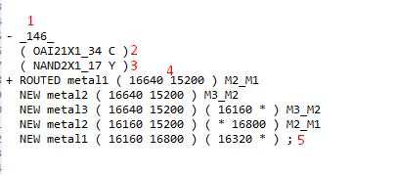

## SPEF Section:

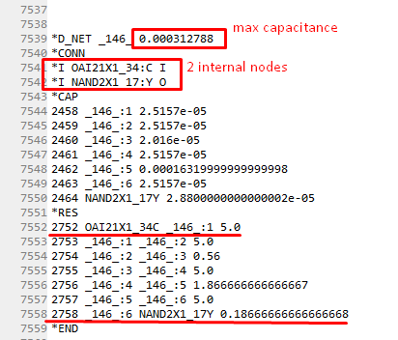

## Test DEF VS. SPEF

|  |  |  |  |  |
| --- | --- | --- | --- | --- |
|  | DEF | SPEF | Expected | Status |
| Net name | _146_ | _146_ | _146_ | ✔ |
| First input (internal or primary port) | Internal | I | I | ✔ |
| Second input (internal or primary port) | Internal | I | I | ✔ |
| The use of the previous node as the starting node for all segments | Each end coordinate is the starting coordinate for the following row | This was shown with the repetition of the second node in every row in the RES section | The behavior observed was exactly as expected | ✔ |
| Number of net internal nodes to be created | According to the DEF file, we have 7 segments and thus, we should have 8 nodes (2 of which are known: pins) | According to the SPEF file, we have created 6 intermediate nodes | 6 nodes to be created. _146_:1 up to _146_:6 | ✔ |

## Verify parsing:

### Check first pin connectivity: pin C in cell OAI21X1_34

Required pin coordinate (as per DEF file): (16640, 15200) (‏✔)

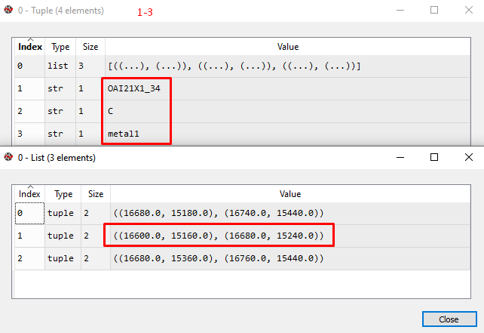

### Check second pin connectivity: pin Y in cell NAND2X1_17

Required pin coordinate (as per DEF file): (16320, 16800) (‏✔)

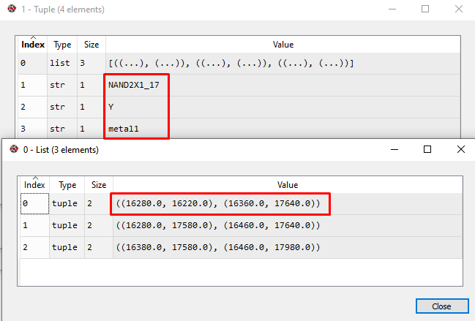

## Check max capacitance calculation

Max capacitance = 4(2.5157e-05) + 2.016e-5 + 0.0001632 + 2.88e-5 = 3.12788e-4

|  |  |  |  |
| --- | --- | --- | --- |
|  | SPEF | Calculated | Status |
| maxC | 0.000312788 | 3.12788e-4 | ✔ |

## Why use this test case?

We used this test case for general purpose testing of the project. It tests the project on many levels. It tests for:

* The DEF and LEF parsing
* The analysis of a routed nets and the connectivity of the pins (implies the correctness of orientation)
* The SPEF file generated meets the standards
* The consistency between the SPEF and DEF files
* The calculation and analysis of the RC values